25.9.10 Editors - Properties Editor - Particle Properties Tab - Hair - Hair Dynamics panel
Hair Dynamics panel 1
Quality Steps 1
Pin Goal Strength 1
Collisions 1
Quality 1
Distance 2
Impulse Clamping 2
Collision Collection 2
Structure 2
Vertex Mass 2
Stiffness 2
Random 2
Damping 2
Volume 2
Air Drag 2
Internal Friction 2
Voxel Grid Cell Size 3
Density Target 3
Density Strength 3

Hair Dynamics panel
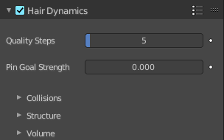
Hair particles can have dynamic properties using physics. To enable hair physics, click the checkbox beside Hair Dynamics.

Quality Steps
Quality of the simulation in steps per frame (higher is better quality but slower).

Pin Goal Strength
Spring stiffness of the vertex target position.
Warning! If you use motion blur in your animation, you will need to bake one extra frame past the last frame which you will be rendering.

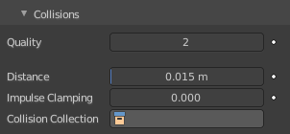
Collisions

Quality
A general setting for how fine and good a simulation you wish. Higher numbers take more time but ensure less tears and penetrations through the cloth.

Distance
The distance another object must get to the cloth for the simulation to repel the cloth out of the way. Smaller values might cause errors but provide some speed-up while larger will give unrealistic results if too large and can be slow. It is best to find a good in between value.

Impulse Clamping
Prevents explosions in tight and complicated collision situations by restricting the amount of movement after a collision.

Collision Collection
Only objects that are a part of this Collection can collide with the cloth. Note that these objects must also have Collision physics enabled.

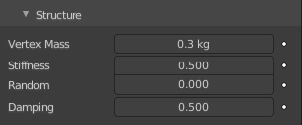
Structure

Vertex Mass
Value for the mass of the hair.

Stiffness
Controls the bending stiffness of the hair strands.

Random
Random stiffness of hair.

Damping
Damping of bending motion.

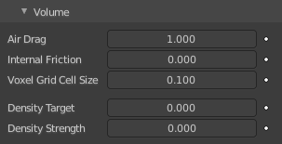
Volume
Some phenomena of real-world hair can be simulated more efficiently using a volumetric model instead of the basic geometric strand model. This means constructing a regular grid such as those used in fluid simulations and interpolating hair properties between the grid cells.

Air Drag
Controls how thick the air is around the hair causing the hair to flow slower.

Internal Friction
Amount of friction between individual hairs.

Voxel Grid Cell Size
Size of the voxel grid cells for interaction effects.

Density Target
Maximum density if the hair.

Density Strength
The influence that the Density Target has on the simulation.

